Courier Management System (CMS)

User Story
Courier and logistics companies can find it difficult to manage shipments and deliveries when they depend on manual work and separate systems. Without one central tracking system, it is harder to follow parcels in real time, so customers may receive updates late and have less visibility. Manually assigning delivery agents can also create scheduling conflicts and delays. In addition, without automatic notifications, customers may not receive important status information on time. Limited performance reports make it harder for managers to understand daily operations. Handling several branches is also more difficult when there is no common platform. Overall, these issues can reduce productivity, affect customer satisfaction, create operational delays, and increase business costs.

1. INTRODUCTION

1.1 Project Overview
Courier and logistics companies face challenges in efficiently managing shipments and deliveries due to manual operations and disconnected systems. These issues lead to delayed updates, poor customer visibility, and operational inefficiencies.
The Courier Management System (CMS) is a cloud-based solution built on Salesforce. It brings shipment booking, tracking, delivery-agent assignment, automatic status updates, billing, and analytics into one place. This centralized approach helps the organization work more efficiently, gives customers better service, and provides managers with useful real-time information.

1.2 Purpose
The main purpose of the Courier Management System (CMS) is to automate and bring courier operations together on the Salesforce platform. It replaces disconnected manual activities with one digital system for shipment booking, real-time tracking, delivery-agent assignment, automatic notifications, billing, and performance reports. Because shipments from different branches can be managed in one place, managers get better visibility, customers receive clearer updates, and delays or data-entry errors can be reduced. The reports and analytics also help managers make quicker decisions.
The overall aim is to improve service efficiency, customer satisfaction, and business performance.

2. IDEATION PHASE

2.1 Problem Statement (Customer Problem Statement Template)
PS | I am  (Customer) | I’m trying to | But | Because | Which makes me  feel
PS-1 | Branch Manager | manage shipments efficiently | tracking is manual | systems are disconnected | stressed
PS-2 | Customer | track parcels | updates are delayed | no centralized system | uncertain
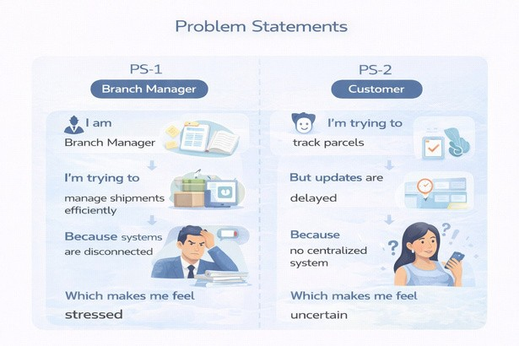

2.2 Empathy Map Canvas
User Persona: Branch Manager
Think & Feel: Concerned about delays & errors
Hear: Customer complaints
See: Registers & spreadsheets
Say & Do: Manual follow-ups
Pain: Delivery conflicts & missed updates
Gain: Automated tracking & dashboards
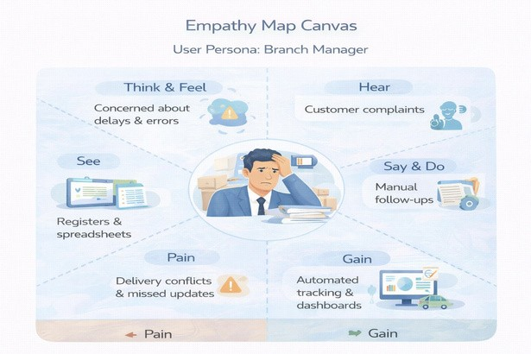
Figure — Original project screenshot/visual

2.3 Brainstorming & Idea Prioritization

Ideas Considered
- Manual registers
- Spreadsheet tracking
- Standalone portal Salesforce CRM

Final Selection
Salesforce CRM selected due to:
- Automation
- Scalability
- Real-time visibility
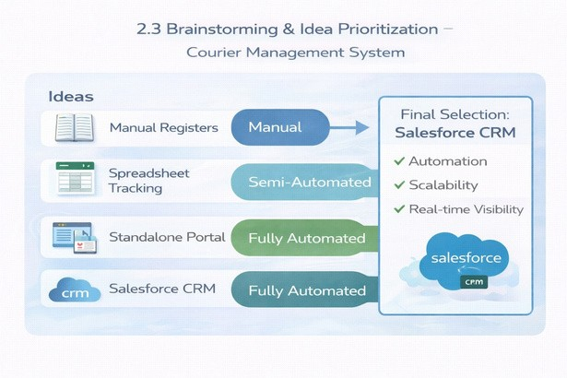

3. REQUIREMENT ANALYSIS PHASE

3.1 Customer Journey Map

Stages
Booking → Shipment Creation → Agent Assignment → Transit → Delivery Update → Invoice → Reporting
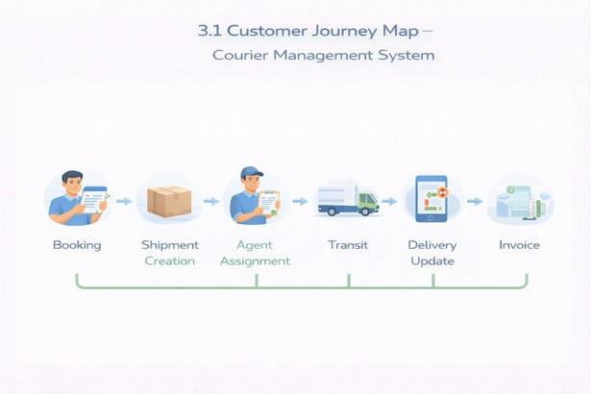

3.2 Solution Requirements

Functional Requirements
FR No | Requirement
FR-1 | Customer management
FR-2 | Shipment booking
FR-3 | Delivery agent assignment
FR-4 | Real-time status updates
FR-5 | Invoice generation
FR-6 | Reports & dashboards

Non-Functional Requirements
NFR | Description
Usability | Easy Lightning interface
Security | Role-based access control
Reliability | Error-free automation
Performance | Fast tracking updates
Availability | 24/7 cloud access
Scalability | Supports growing branches

3.3 Data Flow Diagram

Flow
Customer Input → Shipment Creation → Validation → Agent Assignment → Delivery Update → Invoice → Reports
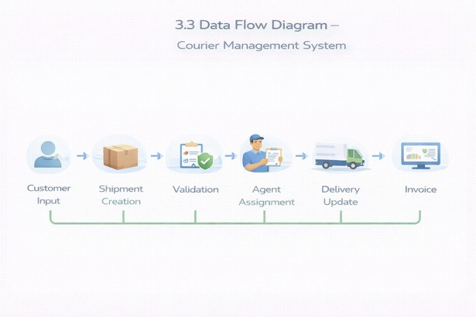

3.4 Technology Stack
Layer | Technology
UI | Salesforce Lightning
Logic | Salesforce Flows
Database | Salesforce Objects
Automation | Validation Rules, Flows
Security | Profiles, Roles
Reporting | Reports & Dashboards

4. PROJECT DESIGN PHASE

4.1 Problem–Solution Fit
CMS eliminates fragmented courier operations by automating shipment tracking, delivery assignment, billing, and reporting within a centralized Salesforce platform.
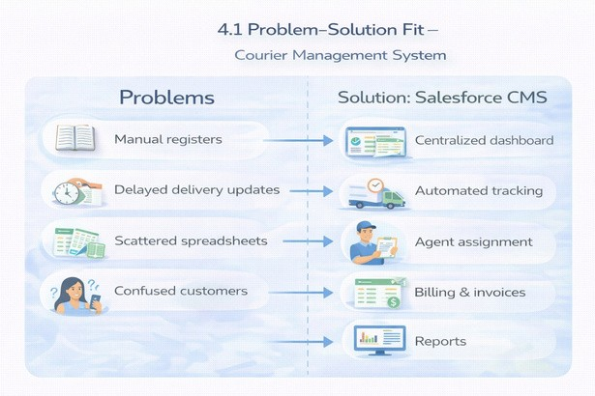

4.2 Proposed Solution

Functional Requirements
Parameter | Description
Problem | Manual shipment management
Solution | Salesforce CMS
Innovation | Automated tracking & billing
Impact | Faster deliveries
Business Model | Courier services
Scalability | Multi-branch ready

4.3 Solution Architecture

Components
- Customer Object
- Shipment Object
- Delivery Agent Object
- Branch Object
- Delivery Update Object
- Invoice Object
- Flows
- Reports
- Dashboards
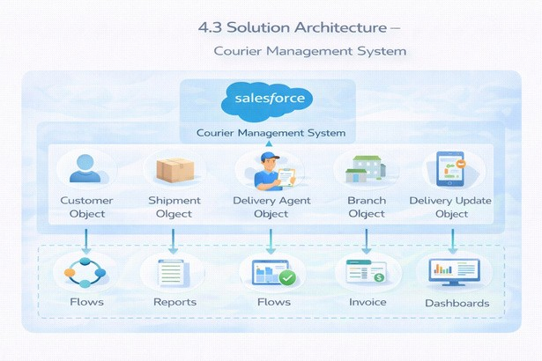

5. PROJECT PLANNING & SCHEDULING

5.1 Project Planning
- Agile methodology
- Epics → Stories → Story Points
- Sprint-based execution
- Velocity calculation used for estimation
Product Backlog, Sprint Schedule, and Estimation (4 Marks) Use the below template to create product backlog and sprint schedule.
Sprint | Functional  Requirement  (Epic) | User  Story  Number | User Story / Task | Story  Points | Priority | Team  Members
Sprint-1 | Developer  Setup | USN-1 | As a system administrator, I want to create and configure a Salesforce developer account so that I can set up and deploy the Courier Management System. | 3 | High | Member1
Sprint-2 | Data  Modeling | USN-2 | As an admin, I want to create Customer, Shipment, Delivery Agent, Branch, and Invoice objects with proper relationships so that courier data is stored and managed efficiently. | 5 | High | Member2
Sprint | Functional  Requirement  (Epic) | User  Story  Number | User Story / Task | Story  Points | Priority | Team  Members
Sprint-2 | Data  Modeling | USN-3 | As a staff member, I want tabs and a Lightning App for all courier modules so that I can easily navigate and perform daily operations. | 5 | High | Member3
Sprint-3 | Automation | USN-4 | As a system, I want to validate shipment details such as delivery dates, addresses, and mandatory fields so that incorrect or incomplete records are prevented. | 3 | High | Member4
Sprint-3 | Automation | USN-5 | As a dispatcher, I want automated flows for shipment status updates and agent assignment so that deliveries are processed faster without manual intervention. | 3 | High | Member4
Sprint-4 | Security | USN-6 | As an administrator, I want role-based access control for managers, agents, and staff so that sensitive shipment and billing data is secure. | 5 | High | Member2
Sprint-5 | Reports | USN-7 | As a branch manager, I want reports showing delivery performance, shipment status, and revenue so that I can monitor operations and make informed decisions. | 4 | High | Member3
Sprint-6 | Dashboards | USN-8 | As a branch manager, I want dashboards showing delivery performance, shipment status, and revenue so that I can monitor operations and make informed decisions. | 4 | Medium | Member4

Project Tracker, Velocity & Burndown Chart (4 Marks)
Sprint | Total Story  Points | Duration | Sprint Start  Date | Sprint End Date  (Planned) | Story Points Completed  (as on Planned End Date) | Sprint Release  Date (Actual)
Sprint-1 | 20 | 6 Days | 24 Oct 2022 | 29 Oct 2022 | 20 | 29 Oct 2022
Sprint-2 | 20 | 6 Days | 31 Oct 2022 | 05 Nov 2022
Sprint-3 | 20 | 6 Days | 07 Nov 2022 | 12 Nov 2022
Sprint-4 | 20 | 6 Days | 14 Nov 2022 | 19 Nov 2022

6. PROJECT DEVELOPMENT PHASE

What you’ll learn
- Real-time Salesforce project implementation
- Designing custom objects and relationships
- Creating page layouts & record types
- Writing validation rules
- Building automation with flows
- Developing reports & dashboards
- Setting up security with profiles, permission sets, and sharing
- End-to-end application testing

Milestone 1: Salesforce Account

Introduction
New to Salesforce and unsure where to start? Curious how real business applications—like loan processing and payment tracking—can be built on the platform? You’re in the right place.
Welcome to the Loan Management System project!
Salesforce provides useful tools for automating work, improving accuracy, and managing customer-related operations. In this project, you will learn how Salesforce can organize business workflows from the beginning of a customer process through approvals, tracking, and document verification.
What Is Salesforce?
Salesforce is a cloud platform that helps organizations manage customers, services, business activities, analysis, and communication. It provides tools that allow teams to work from different locations, manage customer and prospect information, collaborate with employees and partners, and keep business data securely in the cloud.
Activity 1: Creating Developer Account Creating a developer org in Salesforce.
- Go to https://developer.salesforce.com/signup
- On the sign up form, enter the following details:
- First name & Last name
- Email
- Job Title: Developer
- Company: College Name
- Country: India
Click on Sign me up after filling these.
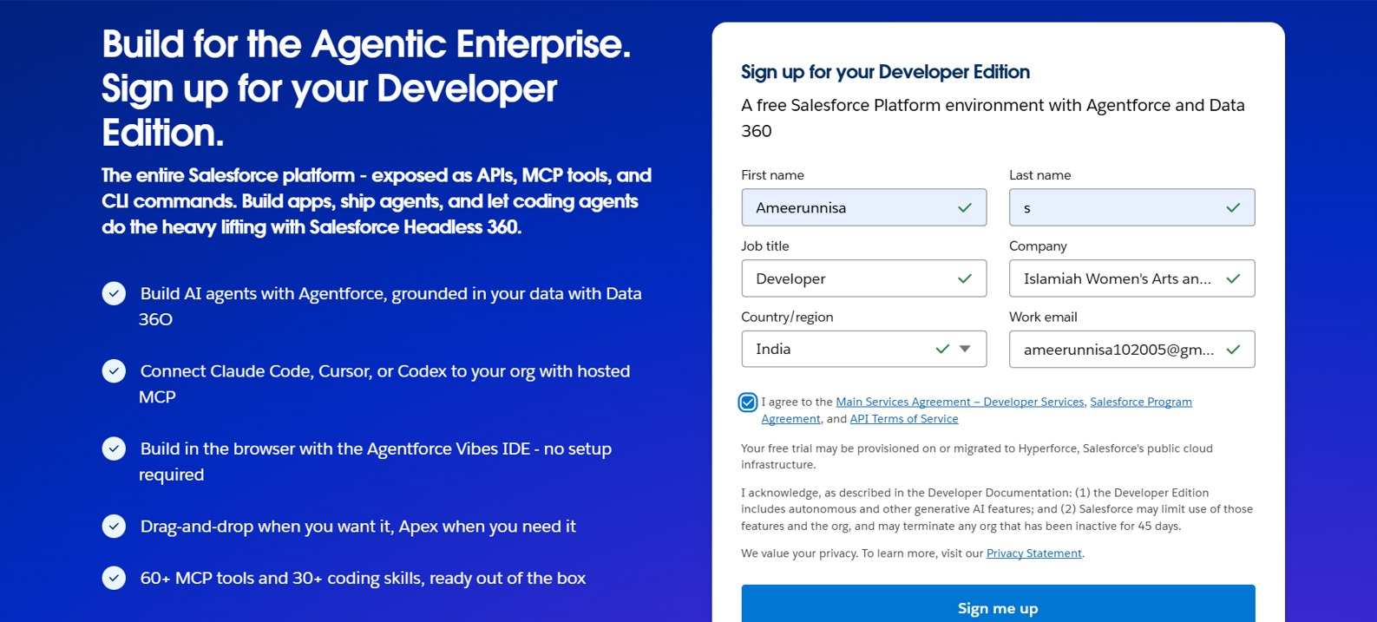

Activity 2: Account Activation
- Go to the inbox of the email that you used while signing up. Click on the verify account to activate your account.
The email may take 10–30 mins and sometimes 2 hours.
- Click on Verify Account.
- Give a password and answer a security question and click on change password.
- Then you will redirect to your Salesforce setup page.

Milestone 2: Object
What is an object?
Salesforce objects are database tables that permit you to store data that is specific to an organization. It consists of fields (columns) and records (rows).

Custom Objects Created
- Customer__c – stores customer personal and contact information
- Shipment__c – manages parcel details, source, destination, and tracking information
- Delivery_Agent__c – maintains delivery agent profiles and branch details
- Branch__c – represents courier branch offices
- Delivery_Update__c – stores status updates for each shipment
- Invoice__c – manages billing details for delivered shipments

Relationships
- Customer → Shipment (Lookup)
- Shipment → Delivery_Agent (Lookup)
- Delivery_Agent → Branch (Lookup)
- Delivery_Update → Shipment (Master-Detail)
- Invoice → Shipment (Lookup)
Steps to Implement

Activity 1: Create Customer Object
Click Setup → Object Manager → Create → Custom Object
Enter the following details:
- Label: Customer
- Plural Label: Customers
- Record Name: Customer Name (Text)
Under Optional Features:
- Enable Allow Reports
- Enable Track Field History
- In Search Status check the box Allow Search
- In Object Creation Options check the box Add Notes and Attachments related list to default page layout Select Save to finish.

Activity 2: Create Shipment Object
Open Setup → Object Manager → Create → Custom Object
Enter:
- Label: Shipment
- Plural Label: Shipments
- Record Name: Tracking Number (Auto Number)
- Example Format: SHP-{00000}
- Starting Number: 0
Enable:
- Allow Reports • Track Field History Click Save.
Activity 3: Create Delivery_Agent Object Open Setup → Object Manager → Create → Custom Object
Enter:
- Label: Delivery Agent
- Plural Label: Delivery Agents • Record Name: Agent Name (Text)
Enable:
- Allow Reports • Track Field History Click Save.

Activity 4: Create Branch Object
Open Setup → Object Manager → Create → Custom Object
Enter:
- Label: Branch
- Plural Label: Branches • Record Name: Branch Name (Text)
Enable: • Allow Reports Click Save.
Activity 5: Create Delivery_Update Object Open Setup → Object Manager → Create → Custom Object
Enter:
- Label: Delivery Update
- Plural Label: Delivery Updates
- Record Name: Update Number (Auto Number)
- Example Format: UPD-{0000}
- Starting Number: 0
Enable:
- Allow Reports
- Track Field History Click Save.

Activity 6: Create Invoice Object
Open Setup → Object Manager → Create → Custom Object
Enter:
- Label: Invoice
- Plural Label: Invoices
- Record Name: Invoice Number (Auto Number)
- Example Format: INV-{0000}
- Starting Number: 0
Enable:
- Allow Reports
- Track Field History Click Save.

Milestone 3: Tabs

Tab
Tabs in Salesforce help users view the information at a glance. It displays the data of objects and other web content in the application.

Activity 1: Creating a Tab for Customer Object
- Click Home, type Tabs in Quick Find, and select Tabs.
- Under Custom Object Tabs, click New.
- For Object, select Customer.
- For Tab Style, choose any icon.
- Leave all default settings as they are.
- Select Next, Next, and Save.

Activity 2: Creating a Tab for Shipment Object
- Click Home, type Tabs in Quick Find, and select Tabs.
- Under Custom Object Tabs, click New.
- For Object, select Shipment.
- For Tab Style, choose any Tab Style.
- Leave all default settings as they are.
- Select Next, Next, and Save.

Activity 3: Creating a Tab for Delivery Agent Object
- Click Home, type Tabs in Quick Find, and select Tabs.
- Under Custom Object Tabs, click New.
- For Object, select Delivery Agent.
- For Tab Style, pick any Tab Style.
- Leave all default settings as they are.
- Select Next, Next, and Save.

Activity 4: Creating a Tab for Branch Object
- Click Home, type Tabs in Quick Find, and select Tabs.
- Under Custom Object Tabs, click New.
- For Object, select Branch.
- For Tab Style, choose any Tab Style. • Leave all default settings as they are.
- Select Next, Next, and Save.

Activity 5: Creating a Tab for Delivery Update Object
- Click Home, type Tabs in Quick Find, and select Tabs.
- Under Custom Object Tabs, click New.
- For Object, select Delivery Update.
- For Tab Style, select any Tab Style.
- Leave all default settings as they are.
- Select Next, Next, and Save.

Activity 6: Creating a Tab for Invoice Object
- Click Home, type Tabs in Quick Find, and select Tabs.
- Under Custom Object Tabs, click New.
- For Object, select Invoice.
- For Tab Style, select any Tab Style.
- Leave all default settings as they are.
- Select Next, Next, and Save.

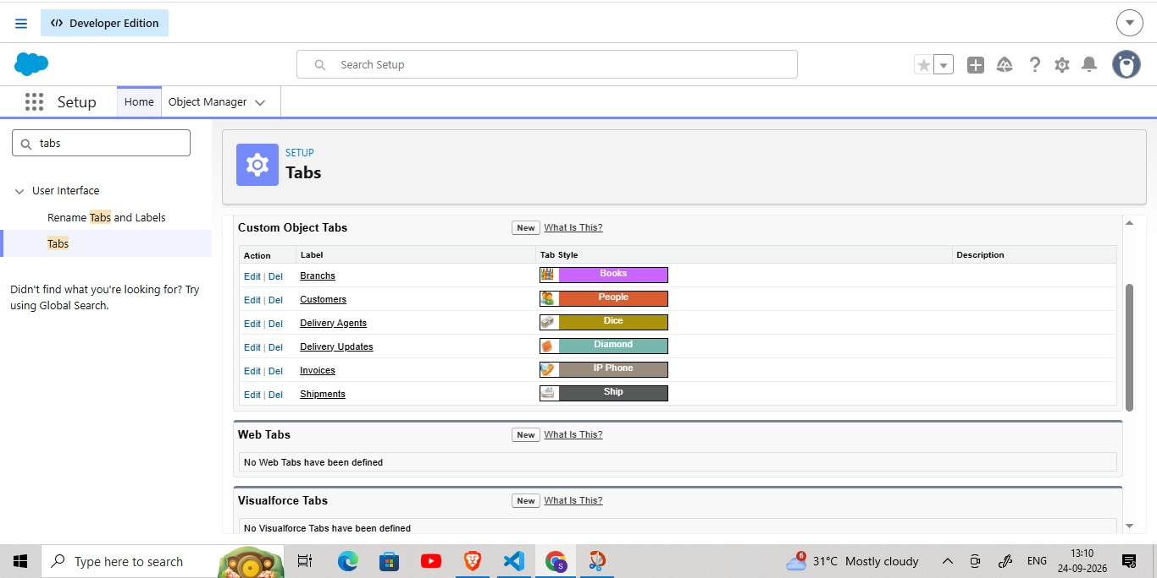

Milestone 4: Fields & Relationships

What are fields?
Fields in Salesforce represent what the columns represent in relational databases. It can store data values which are required for a particular object in a record.

Activity 1: Creation of fields for the Customer Object

Field Name | API Name | Data Type | Required | Description
Customer Name | Name | Text | Yes | Full name of customer
Email | Email__c | Email | Yes | Customer email
Phone | Phone__c | Phone | Yes | Customer contact number
Address | Address__c | Text Area | Yes | Customer address
Customer Type | Customer_Type__c | Picklist | Yes | Regular / Business
City | City__c | Text | No | Customer city
State | State__c | Text | No | Customer state
Pincode | Pincode__c | Text | No | Postal code
Is Active | Is_Active__c | Checkbox | No | Active status

1. Email (Email Field)
- Open Setup → Object Manager → Customer__c
- Click Fields & Relationships → New
- Select Email → Next
- Field Label: Email
- Check the Required box
- Select Next → Next → Save

2. Phone (Phone Field)
- Setup → Object Manager → Customer__c
- Fields & Relationships → New
- Select Phone → Next
- Field Label: Phone
- Check Required
- Select Next → Next → Save

3. Address (Text Area)
- Setup → Object Manager → Customer__c
- Fields & Relationships → New
- Select Textarea → Next
- Field Label: Address
- Check Required
- Save

4. Customer Type (Picklist)
- Setup → Customer__c → Fields → New
- Picklist → Next
- Field Label: Customer Type
- Enter values: Regular, Business
- Check Required
- Save

5. City (Text)
- Setup → Customer__c → Fields → New
- Text → Next
- Field Label: City
- Save

6. State (Text)
- Setup → Customer__c → Fields → New
- Text → Next
- Field Label: State
- Save

7. Pincode (Text)
- Setup → Customer__c → Fields → New
- Text → Next
- Field Label: Pincode
- Save

8. Is Active (Checkbox)
- Setup → Customer__c → Fields → New
- Checkbox → Next
- Field Label: Is Active
- Save
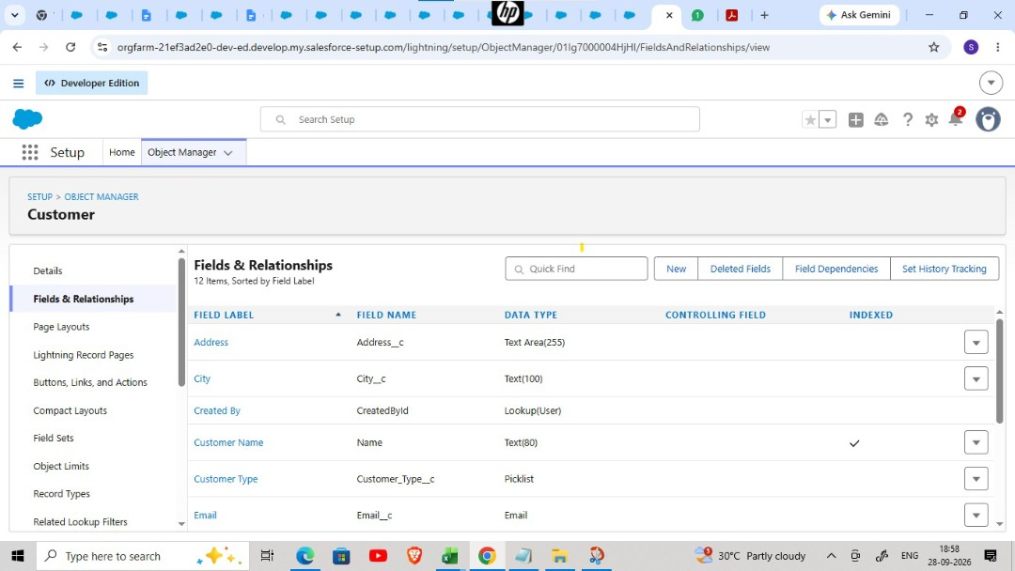

Activity 2: Creation of fields for the Shipment Object

Field Name | API Name | Data Type | Required | Description
Tracking Number | Name | Auto Number | Yes | Unique ID
Customer | Customer__c | Lookup(Customer) | Yes | Related customer
Source Address | Source_Address__c | Text Area | Yes | Pickup location
Destination Address | Destination_Address__c | Text Area | Yes | Delivery location
Weight | Weight__c | Number | Yes | Parcel weight
Price | Price__c | Currency | Yes | Shipping charge
Status | Status__c | Picklist | Yes | Shipment status
Expected Date | Expected_Date__c | Date | Yes | Delivery estimate
Assigned Agent | Assigned_Agent__c | Lookup(Delivery_Agent  ) | No | Delivery agent
Shipment Type | Shipment_Type__c | Picklist | Yes | Domestic/International

Source Address (Text Area)
- Setup → Shipment__c → Fields → New
- Textarea → Next
- Field Label: Source Address
- Mark it as Required, then select Save.

2. Destination Address (Text Area)
- Setup → Shipment__c → Fields → New
- Textarea → Next
- Field Label: Destination Address
- Mark it as Required, then select Save.

3. Weight (Number)
- Setup → Shipment__c → Fields → New
- Number → Next
- Field Label: Weight
- Mark it as Required, then select Save.

4. Price (Currency)
- Setup → Shipment__c → Fields → New
- Currency → Next • Field Label: Price
- Mark it as Required, then select Save.

5. Status (Picklist)
- Setup → Shipment__c → Fields → New
- Picklist → Next
- Field Label: Status
- Values: Booked, In Transit, Out for Delivery, Delivered, Cancelled
- Mark it as Required, then select Save.

6. Expected Date (Date)
- Setup → Shipment__c → Fields → New
- Date → Next
- Field Label: Expected Date
- Mark it as Required, then select Save.

7. Shipment Type (Picklist)
- Setup → Shipment__c → Fields → New
- Picklist → Next
- Field Label: Shipment Type
- Values: Domestic, International
- Mark it as Required, then select Save.

Activity 3: Creation of fields for Delivery_Agent Object
Field Name | API Name | Data Type | Required
Agent Name | Name | Text | Yes
Email | Email__c | Email | Yes
Phone | Phone__c | Phone | Yes
Branch | Branch__c | Lookup | Yes
Status | Status__c | Picklist | Yes
Joining Date | Joining_Date__c | Date | No

1. Email
- Setup → Delivery_Agent__c → Fields → New
- Email → Next
- Field Label: Email
- Mark it as Required, then select Save.

2. Phone
- Setup → Delivery_Agent__c → Fields → New
- Phone → Next
- Field Label: Phone
- Mark it as Required, then select Save.

3. Status (Picklist)
- Values: Active, Inactive, On Leave
- Mark it as Required, then select Save.

4. Joining Date
- Setup → Delivery_Agent__c → Fields → New
- Date → Next
- Field Label: Joining Date
- Save

Activity 4: Creation of fields for Branch Object
Field Name | API Name | Data Type | Required
Branch Name | Name | Text | Yes
Branch Code | Branch_Code__c | Text | Yes
City | City__c | Text | Yes
State | State__c | Text | Yes
Manager Name | Manager_Name__c | Text | No
Create each field using:
- Setup → Branch__c → Fields → New
- Select respective Data Type
- Enter Field Label
- Save
- (Repeat for all fields)

Activity 5: Creation of fields for Delivery_Update Object
Field Name | API Name | Data Type | Required
Update Number | Name | Auto Number | Yes
Shipment | Shipment__c | Master-Detail | Yes
Status | Status__c | Picklist | Yes
Update Date | Update_Date__c | DateTime | Yes
Remarks | Remarks__c | Text | No
Status Picklist Values:
- In Transit
- Out for Delivery
- Delivered
- Delayed

Mark it as Required, then select Save. Activity 6: Creation of fields for Invoice Object
Field Name | API Name | Data Type | Required
Invoice Number | Name | Auto Number | Yes
Shipment | Shipment__c | Lookup | Yes
Amount | Amount__c | Currency | Yes
Invoice Date | Invoice_Date__c | Date | Yes
Payment Status | Payment_Status__c | Picklist | Yes
Payment Status Values:
- Paid
- Unpaid
- Pending
Mark it as Required, then select Save.

Relationships
Child Object | Field | Parent Object | Type
Shipment | Customer__c | Customer | Lookup
Shipment | Assigned_Agent__c | Delivery_Agent | Lookup
Delivery_Agent | Branch__c | Branch | Lookup
Delivery_Update | Shipment__c | Shipment | Master-Detail
Invoice | Shipment__c | Shipment | Lookup
Relationship Creation Steps

Activity 1 – Shipment → Customer
- Setup → Shipment__c → Fields → New

Lookup Relationship
- Related Object: Customer__c
- Field Label: Customer
- Save

Activity 2 – Shipment → Delivery Agent
- Setup → Shipment__c
- New → Lookup
- Object: Delivery_Agent__c
- Label: Assigned Agent
- Save

Activity 3 – Delivery Agent → Branch
- Setup → Delivery_Agent__c
- New → Lookup
- Related Object: Branch__c
- Label: Branch
- Save

Activity 4 – Delivery Update → Shipment
- Setup → Delivery_Update__c
- New → Master-Detail
- Related Object: Shipment__c
- Save

Activity 5 – Invoice → Shipment
- Setup → Invoice__c
- New → Lookup
- Object: Shipment__c
- Save

Milestone 5: Validation Rules
Validation rules check the information when a user tries to save a record. They compare the entered data with defined conditions. If the data does not meet those conditions, Salesforce shows an error message and stops the record from being saved until the problem is corrected.
Activity 1: Create Validation Rules on Customer__c

1. Validation Rule: Email Must Not Be Blank
- Click the Gear icon → Setup
- Go to Object Manager
- Search and select Customer__c
- From the left menu, click Validation Rules
- Click New
- Rule Name: Email_Required
- Make sure Active is selected
Formula:
ISBLANK(Email__c)
- Click Check Syntax
- Error Message: Email is required.
- Error Location: Field → Email
- Select Save to finish.

2. Validation Rule: Phone Must Be 10 Digits
- Setup → Object Manager → Customer__c
- Validation Rules → New
- Rule Name: Validate_Phone_Number
- Make sure Active is selected
Formula:
LEN(Phone__c) <> 10
- Check Syntax
- Error Message: Phone number must be 10 digits.
- Error Location: Field → Phone
- Save

3. Validation Rule: Pincode Must Be 6 Digits
- Setup → Object Manager → Customer__c
- Validation Rules → New
- Rule Name: Validate_Pincode
- Active → Yes Formula:
LEN(Pincode__c) <> 6
- Error Message: Pincode must be 6 digits.
- Location: Field → Pincode
- Save
Activity 2: Create Validation Rules on Shipment__c

1. Validation Rule: Weight Must Be Greater Than Zero
- Setup → Object Manager → Shipment__c
- Click Validation Rules → New
- Rule Name: Validate_Weight
- Active → Checked Formula:
Weight__c <= 0
- Check Syntax
- Error Message: Weight must be greater than zero.
- Location: Field → Weight
Save

2. Validation Rule: Price Must Be Greater Than Zero
- Setup → Object Manager → Shipment__c
- Validation Rules → New
- Rule Name: Validate_Price
- Active → Yes Formula:
Price__c <= 0
- Error Message: Price must be greater than zero.
- Location: Field → Price
- Save

3. Validation Rule: Expected Date Cannot Be in the Past
- Setup → Object Manager → Shipment__c
- Validation Rules → New • Rule Name: Validate_Expected_Date
Formula:
Expected_Date__c < TODAY()
- Check Syntax
- Error: Expected delivery date cannot be in the past.
- Location: Field → Expected Date
- Save
Activity 3: Create Validation Rules on Delivery_Agent__c

1. Validation Rule: Email Must Be Valid
- Setup → Object Manager → Delivery_Agent__c
- Validation Rules → New
- Rule Name: Validate_Agent_Email
- Active → Yes
Formula:
NOT(CONTAINS(Email__c, "@"))
- Error Message: Enter a valid email address.
- Location: Field → Email
- Save
Activity 4: Create Validation Rules on Branch__c

1. Validation Rule: Branch Code Must Not Be Blank
- Setup → Object Manager → Branch__c
- Validation Rules → New • Rule Name: Branch_Code_Required
Formula:
ISBLANK(Branch_Code__c)
- Error Message: Branch Code is mandatory.
- Location: Field → Branch Code
- Save
Activity 5: Create Validation Rules on Delivery_Update__c

1. Validation Rule: Remarks Required If Status is Delayed
- Setup → Object Manager → Delivery_Update__c
- Validation Rules → New
- Rule Name: Remarks_Required_For_Delay
Formula:
AND(
ISPICKVAL(Status__c, "Delayed"),
ISBLANK(Remarks__c)
)
- Error Message: Remarks are required when status is Delayed.
- Location: Field → Remarks
- Save

Milestone 6: Page Layouts
Page Layouts in Salesforce control what a user sees on a record page and how information is organized. They help structure fields, sections, buttons, related lists, and other components in a clean and user-friendly way. By customizing page layouts, we ensure that users can easily enter, update, and view the required data. Activity 1: Edit Page Layout for Customer__c

Steps
- Setup → Object Manager → Customer__c
- Click Page Layouts
- Click the default layout (usually Customer Layout)

Sections to Add & Arrange
- Open the default layout
- In the top palette, click “Section”
- Drag the Section and drop it anywhere on the layout
- A pop-up appears → Fill details: Section Name: “Customer Information”; Layout: 1-Column or 2-Column
(recommended); Tab-Key Order: Top-Down
- Click OK
- The new section will appear on the layout.
- Drop fields inside the section (it will highlight).
- Repeat the same for each field.

Section 1: Customer Information
- Customer Name
- Customer Type
Email
- Phone
- Is Active

Section 2: Address Details
- Address
- City
- State
- Pincode
Edit the layout as needed. Select Save to finish.
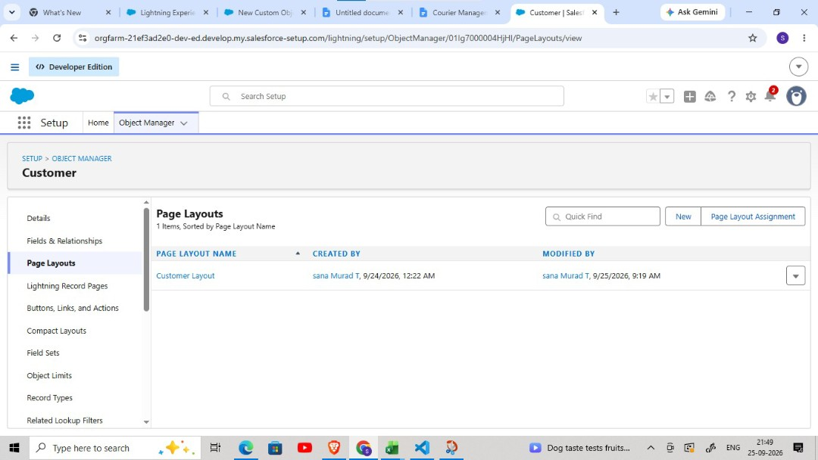
Activity 2: Edit Page Layout for Shipment__c

Steps
- Setup → Object Manager → Shipment__c
- Click Page Layouts
- Open the default Shipment Layout

Section 1: Shipment Details
- Tracking Number
- Customer
- Shipment Type
- Weight
- Price
- Status

Section 2: Address Information
• Source Address

Destination Address

Section 3: Delivery Information
- Expected Date
- Assigned Agent
Arrange fields properly. Click Save.
Activity 3: Edit Page Layout for Delivery_Agent__c

Steps
- Setup → Object Manager → Delivery_Agent__c
- Click Page Layouts
- Open the default Delivery Agent Layout

Agent Details
- Agent Name
- Email
- Phone
- Branch
- Status
- Joining Date

Additional Information
• Related Shipments • Related Delivery Updates Edit → Save.
Activity 4: Edit Page Layout for Branch__c

Steps
- Setup → Object Manager → Branch__c
- Click Page Layouts
- Open the default Branch Layout

Branch Information
- Branch Name
- Branch Code
- City
- State
- Manager Name
Arrange fields. Click Save.
Activity 5: Edit Page Layout for Delivery_Update__c

Steps
- Setup → Object Manager → Delivery_Update__c
- Click Page Layouts
Open the default Delivery Update Layout

Update Information
- Update Number
- Shipment
- Status
- Update Date
- Remarks
Arrange properly. Click Save.
Activity 6: Edit Page Layout for Invoice__c

Steps
- Setup → Object Manager → Invoice__c
- Click Page Layouts
- Open the default Invoice Layout

Invoice Details
- Invoice Number
- Shipment
- Amount
- Invoice Date
- Payment Status
Arrange fields as needed. Click Save.

Milestone 7: Flows
A Salesforce Flow is a visual automation tool used to perform business steps automatically. It can collect information, create or update records, and guide users through a sequence of actions or screens. Flows are created with a visual builder, so many automations can be built without writing code.

Activity 1: Auto-Update Shipment Status When Delivery Update is Created
Scenario: Whenever a Delivery_Update__c record is created, automatically update the related Shipment__c Status with the latest status from Delivery Update.
Part 1: Create the Record-Triggered Flow

Step 1: Open Flow Builder
- Click the Gear Icon → Click Setup
- In the Quick Find box (left side), type Flows
- Click Flows
- Click the New Flow button
- Select Record-Triggered Flow
- Select Create
Step 2: Configure the Start (Trigger) — On the Start panel on the right:
- Object: select Delivery_Update__c
Trigger the Flow When:
- Select A record is created
Condition Requirements: • Choose: None (Always Run the Flow)
Optimize the Flow For:
- Select Actions and Related Records
- Click Done
Part 2: Update Related Shipment Record

Step 3: Add “Update Records” Element
- Click the + icon under the Start element
- Select Update Records
Configure the Update Records Element:
- Label: Update_Shipment_Status
How to Find Records to Update: • Select Specify conditions to identify records
Set Filter Conditions:
- Object: Shipment__c
- Field: Id
- Operator: Equals
- Value: {!$Record.Shipment__c} (This means update the Shipment linked to the Delivery Update) Set Field Values to Update — Add field mapping:
Shipment Field | Value Source
Status__c | {!$Record.Status__c}
(This copies status from Delivery Update to Shipment.) Click Done.
Part 3: Save and Activate

Step 4: Save Flow
- Click Save (top-right)
- Flow Label: Auto_Update_Shipment_Status
- API Name will auto-fill
- Click Save

Step 5: Activate Flow
- Click Activate
- Flow status should show Active
Final Flow Layout:

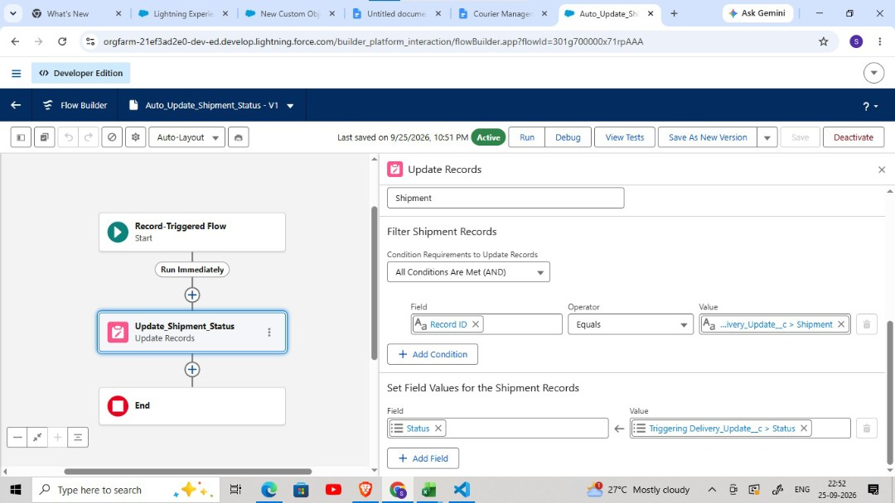

Milestone 8: The Lightning App
What is an App?
Apps in Salesforce are a group of tabs that help the application function by working together as a unit. It has a name, a logo, and a particular set of tabs. The simplest app usually has just two tabs.
Activity 1: Create a Lightning App

Create the Courier Management System App
- From Setup, enter App Manager in the Quick Find and select App Manager.
- Click New Lightning App.
- Enter the Courier Management System as the App Name.
- Upload an image or icon for the app, then click Next.
- Options, leave the default selections and click Next.
- Under Utility Items, leave as it is and click Next.
From Available Items, select the following and move them to Selected Items:
- Customer
- Shipment
- Delivery Agent
- Branch
- Delivery Update
- Invoice
- Reports
- Dashboards
- Select Next.
- From Available Profiles, select System Administrator and move it to Selected Profiles.
Click Save & Finish.
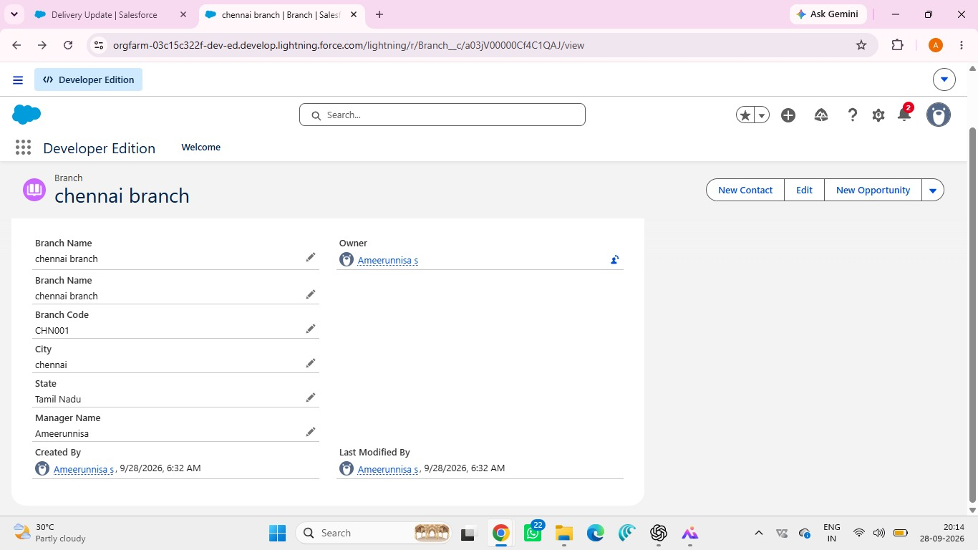

Milestone 9: Profile
What is a profile?
A profile is a group/collection of settings and permissions that define what a user can do in Salesforce. A profile controls “Object permissions, Field permissions, User permissions, Tab settings, App settings, Apex class access, Visualforce page access, Page layouts, Record Types, Login hours & Login IP ranges.”
A profile can be assigned to many users, but users can be assigned a single profile at a time.

Activity 1: Create a Custom Profile – Courier Admin
Create a Custom Profile:
- From Setup, enter Profiles in the Quick Find box.
- Click Profiles.
- Click New Profile.
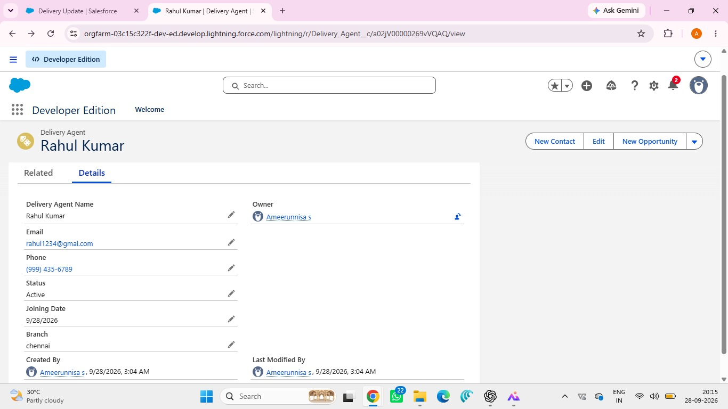
Figure — Original project screenshot/visual
- Select Existing Profile as: System Administrator.
- Enter Profile Name: Courier Admin.
- Select Save to finish.
Why use System Administrator as Base? It already has:
- Modify All Data
- Customize Application
- Full CRUD access on all objects
By cloning it, the Courier Admin profile automatically inherits full access. You can later restrict permissions if required.
Activity 2: Create a Custom Profile – Branch Manager

Steps
- From Setup, enter Profiles in the Quick Find box.
- Click Profiles.
- Click New Profile.
- Select Existing Profile as: Standard Platform User.
- Enter Profile Name: Branch Manager.
- Select Save to finish.
- Click Edit on the Branch Manager profile.

Set App & Tab Settings
- Under Assigned Apps / Custom App Settings, set the default app to: Courier Management System App
- Ensure Visible Tabs Include:
Set these tabs as Default On or Visible:
- Customers
- Shipments
- Delivery Agents
- Branches
- Delivery Updates
- Invoices
- Reports
- Dashboards
Custom Object Permissions — Scroll to Custom Object Permissions and set access as follows:
Object | Permissions to Grant
Customer__c | Create, Read, Edit
Shipment__c | Create, Read, Edit
Delivery_Agent__c | Read, Edit
Branch__c | Read, Edit
Delivery_Update__c | Create, Read, Edit
Invoice__c | Read

Session & Password Settings
Under Session Settings:
- Session Timeout: 2 Hours of Inactivity
Under Password Policies:
- User passwords expire in: Never Expires
- Minimum Password Length: 8
Select Save to finish.
Activity 3: Create a Custom Profile – Delivery Agent

Steps
- Setup → Quick Find → Profiles
- Click New Profile
- Existing Profile: Standard Platform User
- Profile Name: Delivery Agent
- Click Save

App & Tab Access
- Default App: Courier Management System
Visible Tabs:
- Shipments
- Delivery Updates
Object Permissions:
Object | Permissions
Shipment__c | Read, Edit
Delivery_Update__c | Create, Read, Edit
Customer__c | Read
Invoice__c | Read

Restrictions
- No access to Branch editing
- No delete permissions • Limited reporting access Select Save to finish.
Activity 4: Create a Custom Profile – Customer Support

Steps
- Setup → Profiles → New Profile
- Base Profile: Standard User
- Profile Name: Customer Support
Access Configuration — Tabs Visible:
- Customers
- Shipments
- Delivery Updates
Object Permissions:
Object | Access
Customer__c | Read, Edit
Shipment__c | Read, Edit
Delivery_Update__c | Read
Invoice__c | Read

Session Settings
- Session Timeout: 2 Hours
- Password Length: 8
- Click Save
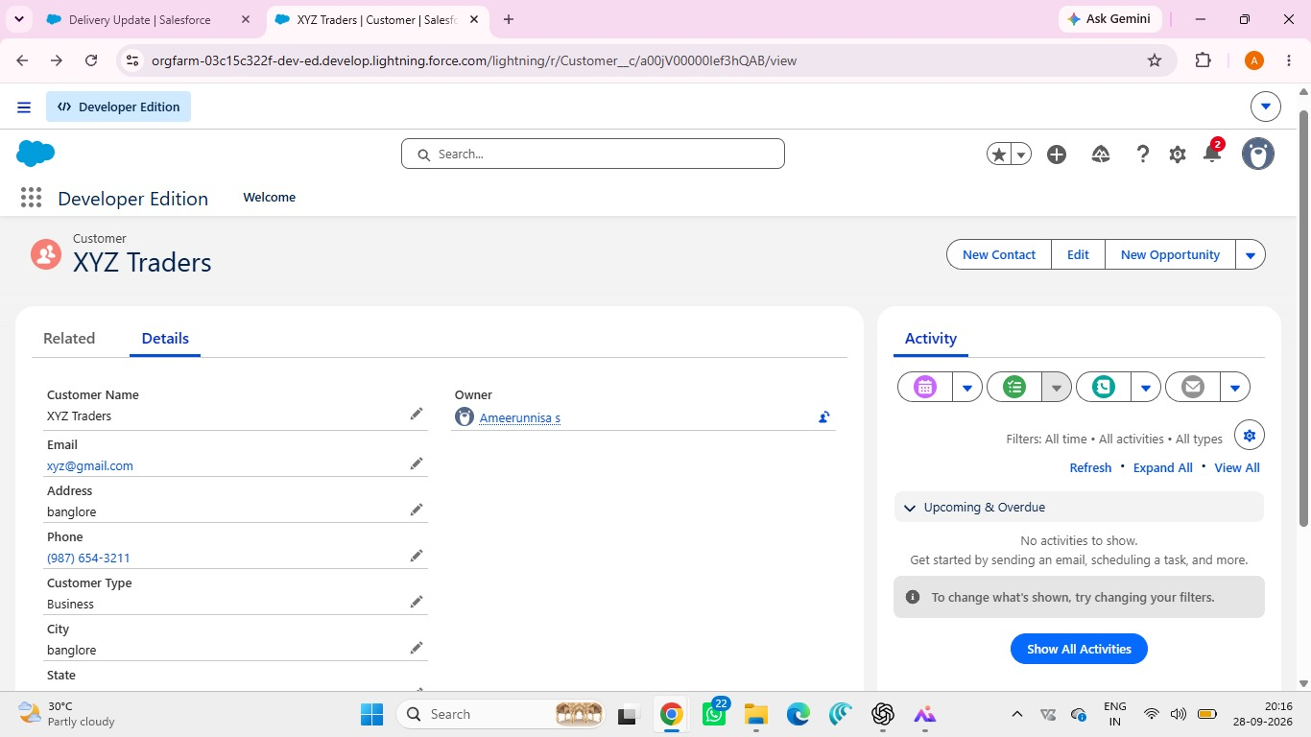

Final Profiles Created in Project
Profile Name | Purpose
Courier Admin | Full system control
Branch Manager | Manage shipments and agents
Delivery Agent | Update delivery status
Customer Support | Handle customers and tracking

Milestone 10: Role
In Salesforce, roles help define the reporting hierarchy and the level of data visibility between users. They are used to organize who can see certain records and how information is shared through the organization. Users higher in the role hierarchy can normally have wider visibility into relevant records.

Activity 1: Creation of Courier Admin Role
Creation of Role:
- From the Quick Find box, search for Roles and click on the Roles option.
- Select Set Up Roles.
- Click on Expand All and click Add Role under CEO.

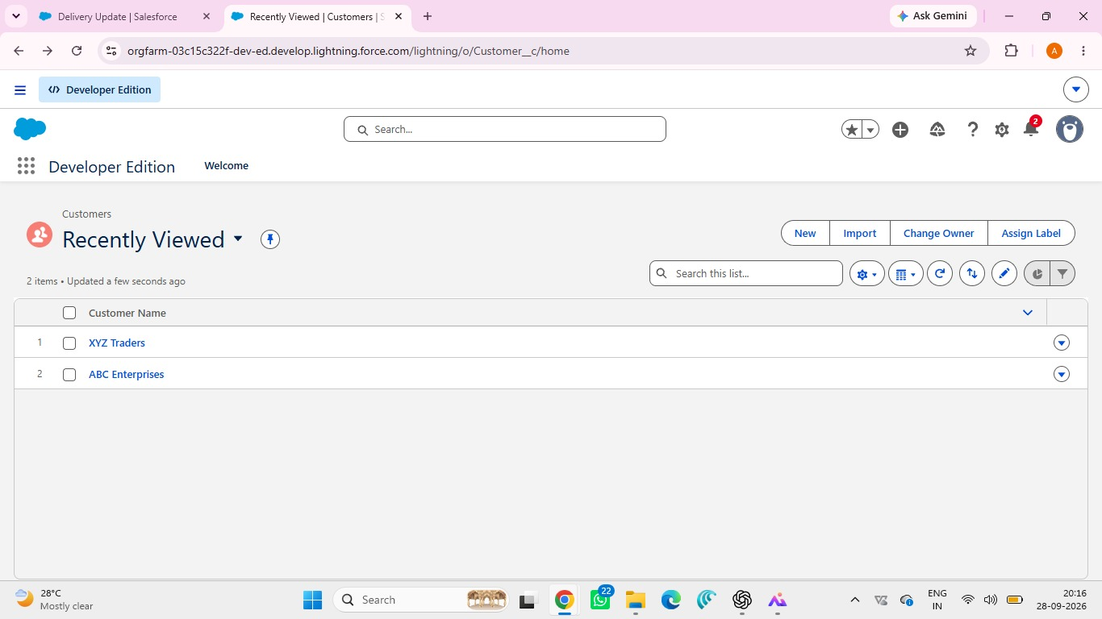

- Give Label as “Courier Admin”.
- The Role Name will auto-populate.
- Select Save to finish.

Activity 2: Creating Branch Manager Role Under Courier Admin Role
- Create a role with the name “Branch Manager”.
- Below the Courier Admin, click on Add Role.
- Enter the label name as “Branch Manager” and the Role Name will automatically populate.
- Select Save to finish.
Activity 3: Creating Delivery Agent Role Under Branch Manager Role

Steps
- Below the Branch Manager role, click on Add Role.
- Enter Label as “Delivery Agent”.
- Role Name will auto-populate.
- Select Save to finish.
Activity 4: Creating Customer Support Role Under Branch Manager

Steps
- Under the Branch Manager role, click on Add Role.
- Enter Label as “Customer Support”.
- Role Name will automatically populate.
- Select Save to finish.

Purpose of This Hierarchy
- Courier Admin – Highest level access to all data
- Branch Manager – Manages branch-level operations
- Delivery Agent – Access only to assigned shipments
- Customer Support – Limited access to customer and shipment tracking
This hierarchy ensures proper data sharing and security in the Courier Management System.

Milestone 11: User
What is a user?
A Salesforce user is a person who has an account and logs in to the Salesforce organization. Users may include sales representatives, managers, support staff, administrators, or IT team members. The account identifies the person and its settings determine which features, applications, and records the user can access.
NOTE: As Salesforce license can only be used by 2 Users at a time in Dev Org, so if you don’t find a Salesforce license then deactivate a user who has a Salesforce license or change the license type from Salesforce to any other. Activity 1: To Create a User

Steps
- From Setup, enter Users in the Quick Find box, then select Users.
- Click New User.

in the Fields:
Field Name | Value
First Name | Enter first name (Example: Ravi)
Last Name | Enter last name (Example: Kumar)
Alias | Give an alias name
Email ID | Enter your personal email ID
Username | Must be in the format: text@text.text and must be unique
Nickname | Give a nickname
Role | Select Courier Admin
User License | Salesforce
Profile | Courier Admin
Select Save to finish.

Activity 2: Creating Other Users
Repeat the same steps as Activity 1 for creating additional users. Use the following details:
User Type | Role | User License | Profile
Branch Manager | Branch Manager | Salesforce | Branch Manager
Delivery Agent | Delivery Agent | Salesforce Platform | Delivery Agent
Customer Support | Customer Support | Salesforce Platform | Customer Support
Example: To create a Branch Manager User
- Open Setup → Users → New User
- Fill details like:
Field | Example Value
First Name | Arjun
Last Name | Reddy
Email | arjun@gmail.com
Field | Example Value
Username | arjun.manager@cms.com
Role | Branch Manager
Profile | Branch Manager
Click Save.
To Create Delivery Agent User: Follow same steps with Role: Delivery Agent; Profile: Delivery Agent.
To Create Customer Support User: Role: Customer Support; Profile: Customer Support.
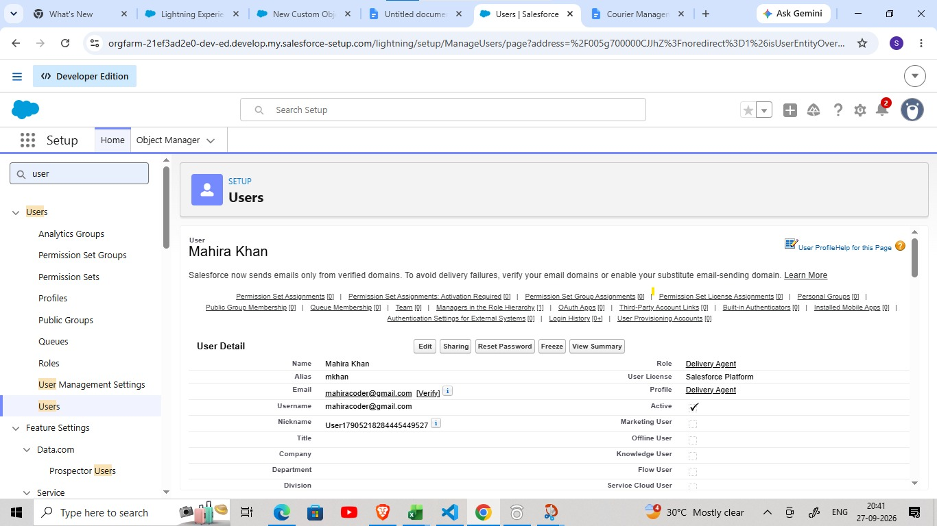

Important Points
Every user must have:
- Unique username
- Valid email
- Assigned Role
- Assigned Profile
- Profiles control permissions
- Roles control data visibility

Milestone 15: Reports & Dashboards
Reports and Dashboards help analyze business data and track courier operations efficiently.
Activity 1: Create Report Types

Step 1: Open Report Types
- Click Gear Icon → Select Setup.
- In Quick Find search Report Types.
- Click New Custom Report Type.

Step 2: Create Shipment Report Type
- Primary Object: Shipment__c
- Label: Shipment Tracking Report
- Category: Reports
- Deployment Status: Deployed
- Select Next → Save

Step 3: Create Customer Report Type
- Primary Object: Customer__c
- Label: Customer Summary Report
- Category: Reports
- Deployment Status: Deployed
- Select Next → Save

Step 4: Create Agent Performance Report Type
- Primary Object: Delivery_Agent__c
- Label: Agent Performance Report
- Category: Reports
- Deployment Status: Deployed
- Select Next → Save
Activity 2: Create Reports
Report 1: Shipment Status Summary Report

Step 1: Create the Report
- Click App Launcher (9 dots) → Search Reports
- Click New Report
- Choose Shipment Tracking Report
- Click Continue
Step 2: Add Columns — Add these fields:
- Tracking Number
- Customer
- Status
- Expected Date
- Assigned Agent

Step 3: Add Filters
- Show Me: All Shipments
- Date Filter: This Month
- Status Filter: Select specific Status (Optional)

Step 4: Group & Summarize
- Group rows by Status__c
- Add summary on Price

Step 5: Save Report
- Click Save & Run
- Name: Shipment Status Summary
- Folder: CMS Reports
Report 2: Agent Performance Report

Step 1: Create Report
- New Report → Choose Agent Performance Report
- Click Continue

Step 2: Add Columns
- Agent Name
- Branch
- Number of Shipments
- Status
Step 3: Group Data
- Group by Delivery_Agent__c

Step 4: Save Report
- Name: Agent Performance Report
- Folder: CMS Reports
- Save & Run
Report 3: Revenue Report

Steps
- Create report using Shipment Tracking Report Type
- Add fields: Tracking Number, Customer, Price, Invoice Status
- Group by: Branch, Month
- Save as: Revenue by Branch Report
Activity 3: Create Dashboard

Step 1: Open Dashboards
- Click App Launcher (9 dots)
- Search Dashboards
- Click New Dashboard

Step 2: Enter Dashboard Details
- Name: Courier Management Dashboard
- Folder: CMS Reports
- Select Create
Activity 4: Add Dashboard Components

Component 1: Shipment Status Overview (Donut Chart)
- Click + Component
- Choose report: Shipment Status Summary
- Visual Type: Donut Chart
- Click Add

Component 2: Agent Performance (Bar Chart)
- Select report: Agent Performance Report
- Chart Type: Bar Chart
- Click Add

Component 3: Revenue by Branch (Column Chart)
- Choose report: Revenue by Branch Report
- Chart Type: Column Chart
- Click Add

Activity 5: Save & Activate Dashboard
- Click Save
- Click Done
Share Dashboard With:
- Courier Admin
- Branch Managers
- Customer Support Team
Final Layout:
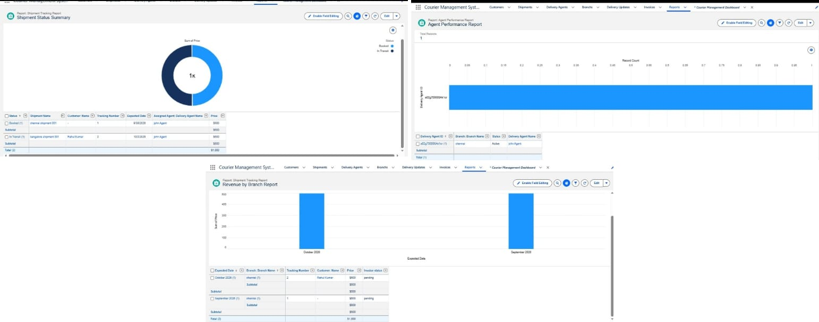
l

7. FUNCTIONAL & PERFORMANCE TESTING

During testing, Salesforce screenshots were used to check record creation, validation rules, delivery-status changes, flow automation, invoice generation, and dashboard displays. The documented scenarios were tested to confirm that the configured features worked as expected and reliably.

8. ADVANTAGES & DISADVANTAGES

Advantages
- Centralized data
- Automated workflows
- Real-time reporting

Disadvantages
- Salesforce dependency
- Requires initial configuration effort

9. CONCLUSION

The Courier Management System successfully digitizes courier operations using Salesforce automation, improving efficiency, accuracy, and customer satisfaction.

10. FUTURE SCOPE

- Mobile tracking app
- GPS integration
- SMS notifications
- AI-based delivery optimization

11. APPENDIX

- Source Code: Salesforce Configuration
- Dataset: Salesforce Objects
- GitHub / Demo: Salesforce Developer Org
Thank You

